## Speeds

You are given a sequence of the speeds of cars in a single-lane street. A car can catch up to the car B, only if B is in front of A and the speed of A is greater than the speed of B, and then the speed of A is lowered to the speed of B. Each gathering of cars is called a group. Your task is to find the sum of the **initial speeds** of the **longest group** of cars (the group with most cars in it). If more than one group with equal length exists, then find the biggest sum of the initial speeds of these groups.

### **Additional notes**

* Cars cannot outrun each other
  + They can only catch up
* The street is very very long and no matter the speed
  + No car with any speed can get out of it until the end of the exam
* Cars with equal speeds do not catch up to each other
  + They do not form a group

### **Example:**

* There are two groups with the biggest length
  + 4 + 6 + 5 = 15
  + 3 + 9 + 100 = 112
* The answer is 112

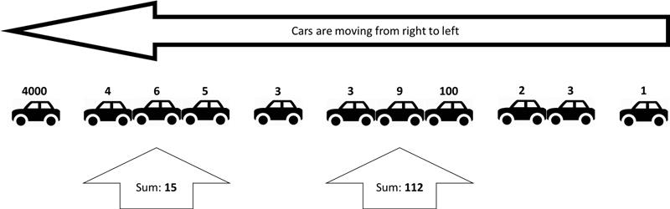

### **Input**

All input data is read from the standard input (the console)

* On the first line will be the number C
  + The number of cars
* On the next C lines there will a single integer number S
  + The speed of each car

### **Output**

The output data is printed on the standard output (the console)

* On the single line on the output print the **sum of the initial speeds of longest group** (the group with most cars)
  + If there are groups with equal length, print the biggest sum

### **Constraints**

* C will always be between 1 and 1000
* Each S will always be between 1 and 1500
* **The input data will always be correct and there is no need to check it explicitly**

### **Sample Tests**

#### **Input**

Copy

11

1500

4

6

5

3

3

9

100

2

3

1

#### **Output**

Copy

112

#### **Input**

Copy

4

1

1

1

1

#### **Output**

Copy

1

#### **Input**

Copy

5

5

4

3

2

1

#### **Output**

Copy

5

#### **Input**

Copy

5

1

2

3

4

5

#### **Output**

Copy

15